Micro Engineering Turnout Frog Wire

Jim Exler, Nampa, ID June 5, 2019

Connecting a wire to the ME cast frog can be a challenge. This is my idea and it seems to work.

1. First I drilled a 0.9 mm hole down through the frog at its narrowest point. I want easy access and the least amount of metal in the frog that I have to heat for the solder joint.

I decided on 20 gauge (0.032”) solid wire (green of course) for the frog. The 0.9 mm (#64) bit I had was hardened to drill circuit boards. With a speed control on my Dremel it worked fine.

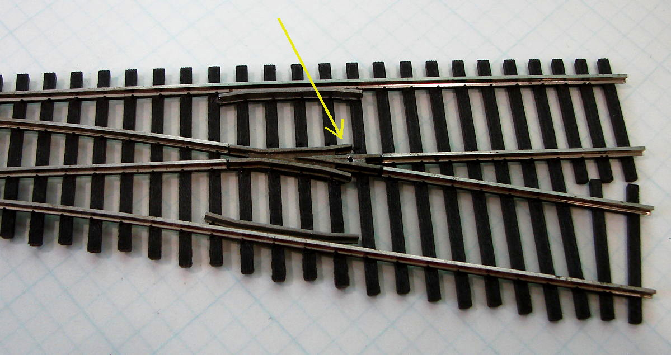

2. Next I stripped about 0.250” of insulation from the wire and inserted it in the hole from the bottom. I also used a couple of heat sinks I had to protect the tie strip from the heat.

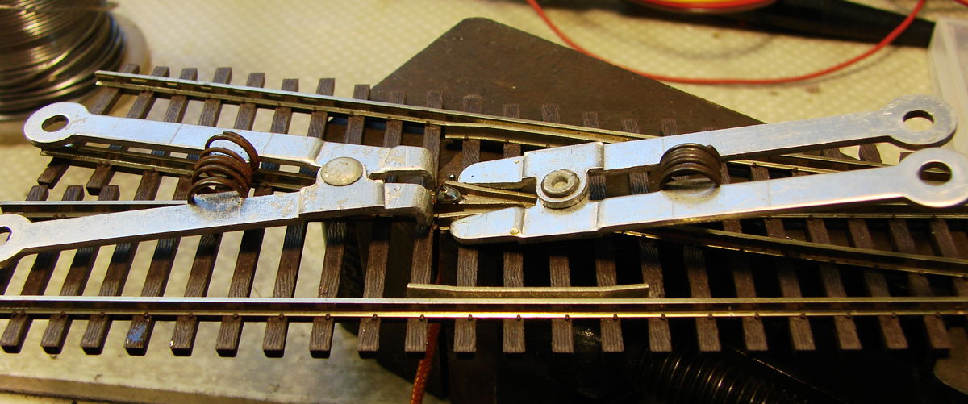

After adding a drop of liquid solder flux to the end of the wire which also went into the hole, I used rosin core solder and with a 45 watt soldering iron, I heated the joint as quickly as possible to avoid melting the tie strip. The solder seemed to flow with a good “wetting”.

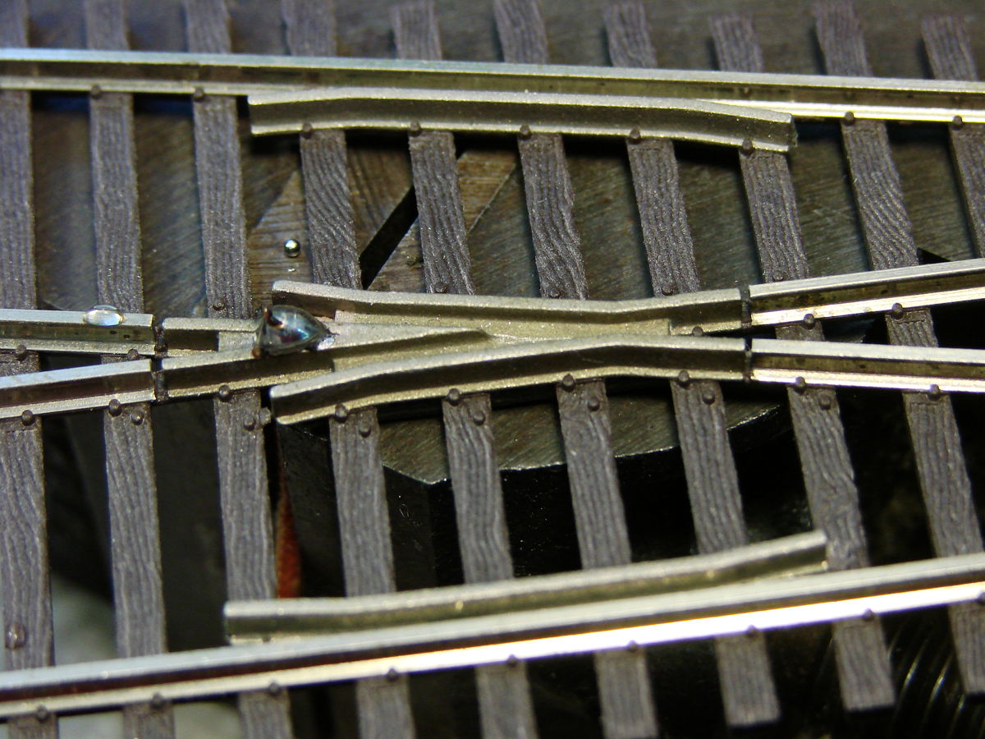

3. I used my rail nippers to remove the bulk of the excess solder and finished up with a knife and a file. As you can see, there is no apparent heat damage to the tie strip or the spike heads.

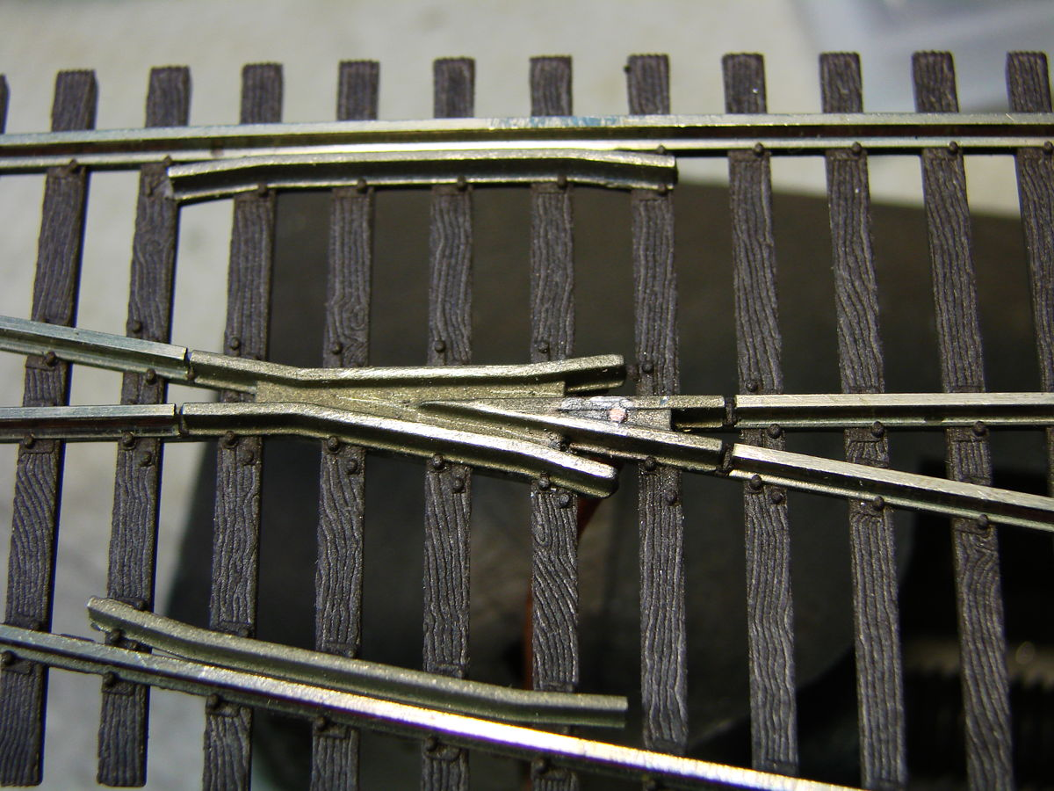

This is probably best done before the turnout is mounted but I think it can also be retrofitted to an installed turnout.

To insure the integrity of the solder joint, I did a pull test on the wire straight down from the frog. I supported the frog with my finger and pulled 3.5 pounds on a scale with no apparent movement.

Another thought would be to grind a groove from the hole toward the gap that would allow the end of the wire to be bent over and laid flush before soldering.